İNTERNET SAYFASI https://srituhobby.com/how-to-make-a-rfid-door-lock-with-arduino/

VİDEOSU https://www.youtube.com/watch?v=GOO84CGBPz8

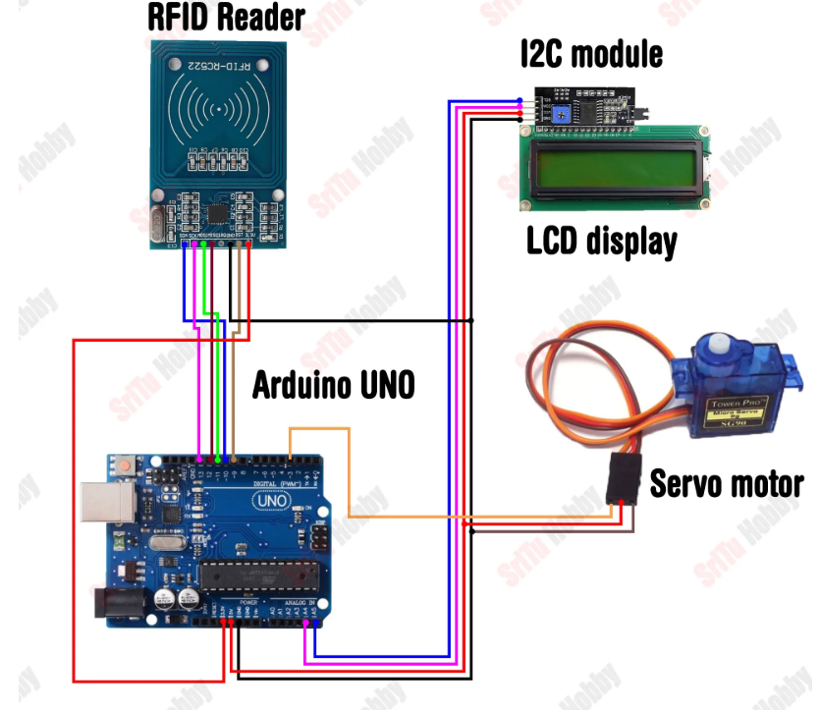

Rif kartı tarama kodu

/*RFID tag scan code
* https://srituhobby.com
*/

#include <LiquidCrystal_I2C.h>
#include <SPI.h>
#include <MFRC522.h>

#define RST_PIN 9
#define SS_PIN 10
byte readCard[4];
byte a = 0;

LiquidCrystal_I2C lcd(0x27, 16, 2);
MFRC522 mfrc522(SS_PIN, RST_PIN);

void setup() {
Serial.begin(9600);
lcd.init();
lcd.backlight();
while (!Serial);
SPI.begin();
mfrc522.PCD_Init();
delay(4);
mfrc522.PCD_DumpVersionToSerial();
lcd.setCursor(2, 0);
lcd.print("Put your card");
}

void loop() {
if ( ! mfrc522.PICC_IsNewCardPresent()) {
return 0;
}
if ( ! mfrc522.PICC_ReadCardSerial()) {
return 0;
}

lcd.clear();
lcd.setCursor(0, 0);
lcd.print("Scanned UID");
a = 0;
Serial.println(F("Scanned PICC's UID:"));
for ( uint8_t i = 0; i < 4; i++) { //
readCard[i] = mfrc522.uid.uidByte[i];
Serial.print(readCard[i], HEX);
Serial.print(" ");
lcd.setCursor(a, 1);
lcd.print(readCard[i], HEX);
lcd.print(" ");
delay(500);
a += 3;
}
Serial.println("");
mfrc522.PICC_HaltA();
return 1;
}

Programın tamamı
/*Door lock system code
* https://srituhobby.com
*/

#include <Servo.h>
#include <LiquidCrystal_I2C.h>
#include <SPI.h>
#include <MFRC522.h>

#define SS_PIN 10
#define RST_PIN 9
String UID = "A3 80 34 16";
byte lock = 0;

Servo servo;
LiquidCrystal_I2C lcd(0x27, 16, 2);
MFRC522 rfid(SS_PIN, RST_PIN);

void setup() {
Serial.begin(9600);
servo.write(70);
lcd.init();
lcd.backlight();
servo.attach(3);
SPI.begin();
rfid.PCD_Init();
}

void loop() {
lcd.setCursor(4, 0);
lcd.print("Welcome!");
lcd.setCursor(1, 1);
lcd.print("Put your card");

if ( ! rfid.PICC_IsNewCardPresent())
return;
if ( ! rfid.PICC_ReadCardSerial())
return;

lcd.clear();
lcd.setCursor(0, 0);
lcd.print("Scanning");
Serial.print("NUID tag is :");
String ID = "";
for (byte i = 0; i < rfid.uid.size; i++) {
lcd.print(".");
ID.concat(String(rfid.uid.uidByte[i] < 0x10 ? " 0" : " "));
ID.concat(String(rfid.uid.uidByte[i], HEX));
delay(300);
}
ID.toUpperCase();

if (ID.substring(1) == UID && lock == 0 ) {
servo.write(70);
lcd.clear();
lcd.setCursor(0, 0);
lcd.print("Door is locked");
delay(1500);
lcd.clear();
lock = 1;
} else if (ID.substring(1) == UID && lock == 1 ) {
servo.write(160);
lcd.clear();
lcd.setCursor(0, 0);
lcd.print("Door is open");
delay(1500);
lcd.clear();
lock = 0;
} else {
lcd.clear();
lcd.setCursor(0, 0);
lcd.print("Wrong card!");
delay(1500);
lcd.clear();
}
}

