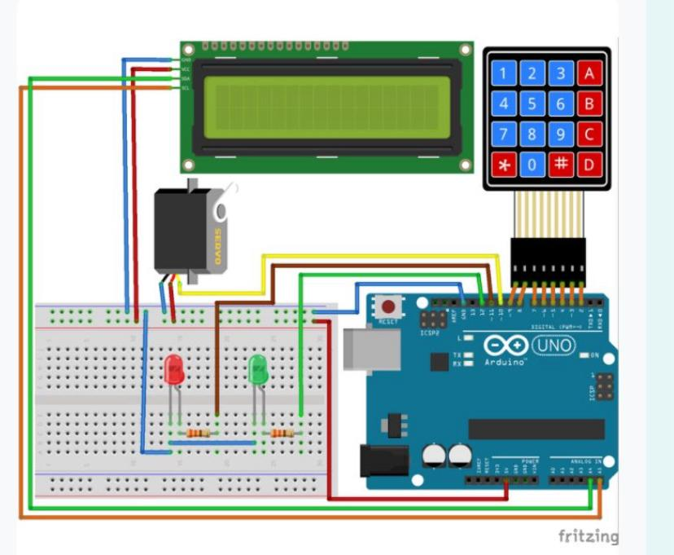

#include <LiquidCrystal_I2C.h>
#include <Wire.h>
#include <Keypad.h>
#include "Servo.h"
LiquidCrystal_I2C lcd(0x27, 16, 2);
Servo ServoKapi;
String sifre = "12345";
int sifreUzunluk = sifre.length();
int ServoPin = 10, ledKirmizi = 11, ledYesil = 12;
char key[4][4] = {
{'1', '2', '3', 'A'},
{'4', '5', '6', 'B'},
{'7', '8', '9', 'C'},
{'*', '0', '#', 'D'}
};
byte Satir[4] = {9, 8, 7, 6};
byte Sutun[4] = {5, 4, 3, 2};
Keypad Tus = Keypad(makeKeymap(key), Satir, Sutun, 4, 4);
void setup() {
lcd.begin();
pinMode(ledYesil, OUTPUT);
pinMode(ledKirmizi, OUTPUT);
ServoKapi.attach(ServoPin);
ServoKapi.write(0);
}
void loop() {
lcd.setCursor(0, 0);
lcd.print("SIFRE GIRIS ICIN");
lcd.setCursor(0, 1);
lcd.print(" # BASINIZ ");
if (Tus.getKey() == '#') {
lcd.clear();
lcd.setCursor(0, 0);
lcd.print(" Lutfen ");
lcd.setCursor(0, 1);
lcd.print(" Bekleyiniz. ");
delay(1000);
SifreGir();
}
}
void SifreGir() {
int uzunluk = 0;
String pass = "";
lcd.clear();
lcd.setCursor(0, 0);
lcd.print("SIFRE:");
while (uzunluk != sifreUzunluk) {
char btus = Tus.getKey();
if (btus != NO_KEY) {
lcd.print(btus);
pass += btus;
uzunluk++;
}
}
lcd.setCursor(0, 1);
if (sifre == pass) {
lcd.print(" SIFRE DOGRU ");
ServoKapi.write(90);
digitalWrite(ledYesil, 1);
delay(5000);
digitalWrite(ledYesil, 0);
ServoKapi.write(0);
}
else {
lcd.print(" SIFRE YANLIS ");
digitalWrite(ledKirmizi, 1);
delay(3000);
digitalWrite(ledKirmizi, 0);
}
}

